Modem

🌐 What is a Modem?
# Source: Chatgpt (GPT‑5 Mini) at [12/18/2025]
A Modem (short for Modulator-Demodulator) is a device that allows computers or routers to connect to the internet over telephone lines, cable systems, or fiber. It converts digital signals from your computer/network into analog signals for transmission over traditional infrastructure — and vice versa.

🔄 What a Modem Does:
# Source: Chatgpt (GPT‑5 Mini) at [12/18/2025]
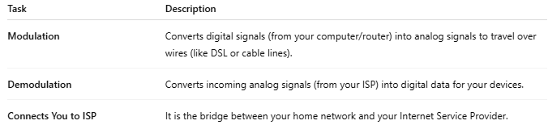

Task | Description
Modulation | Converts digital signals (from your computer/router) into analog signals to travel over wires (like DSL or cable lines).
Demodulation | Converts incoming analog signals (from your ISP) into digital data for your devices.
Connects You to ISP | It is the bridge between your home network and your Internet Service Provider.

📶 Example Setup
# Source: Chatgpt (GPT‑5 Mini) at [12/18/2025]
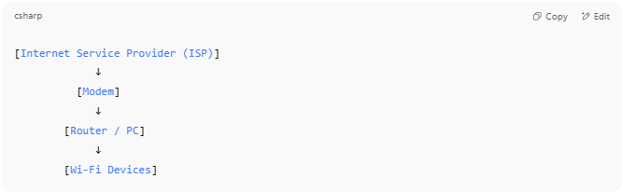

[Internet Service Provider (ISP)]
↓
[Modem]
↓
[Router / PC]
↓
[Wi-Fi Devices]

- The modem connects to the ISP (via DSL, cable, or fiber).
- It provides internet to a router, which shares it with your devices.

🧱 Types of Modems
# Source: Chatgpt (GPT‑5 Mini) at [12/18/2025]
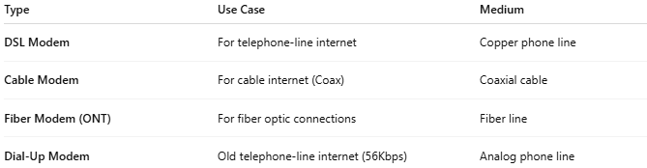

Type | Use Case | Medium
DSL Modem | For telephone-line internet | Copper phone line
Cable Modem | For cable internet (Coax) | Coaxial cable
Fiber Modem (ONT) | For fiber optic connections | Fiber line
Dial-Up Modem | Old telephone-line internet (56Kbps) | Analog phone line

🆚 Modem vs Router
# Source: Chatgpt (GPT‑5 Mini) at [12/18/2025]
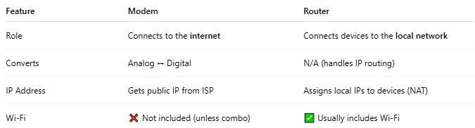

Feature | Modem | Router
Role | Connects to the internet | Connects devices to the local network
Converts | Analog ↔ Digital | N/A (handles IP routing)
IP Address | Gets public IP from ISP | Assigns local IPs to devices (NAT)
Wi-Fi | ❌ Not included (unless combo) | ✅ Usually includes Wi-Fi
🔸 Many homes use a modem-router combo, which combines both functions in one box.

✅ Summary
# Source: Chatgpt (GPT‑5 Mini) at [12/18/2025]
- A modem is your gateway to the internet.
- It talks to your ISP, converting data between formats.
- You still need a router to connect multiple devices and create a Wi-Fi network.

